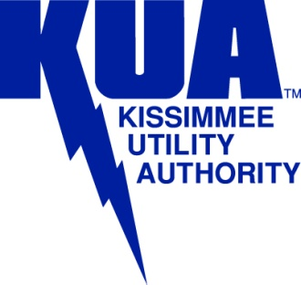 | Engineering & Operations Department
P.O. Box 423219 Kissimmee, Florida 34742-3219
407/933-7777 Fax 407/933-4178
Release from Liability Form

The Property Owner, _____________________________ of thus stated address,
________________________________________________ do hereby release the Kissimmee Utility Authority (KUA) from liability of damages that may potentially occur due to KUA accessing the above stated property for the purpose of installing a secondary wood pole in order to provide more vertical clearance from the road to the meter socket stack. KUA will try to work in a manner to minimize the impact of equipment damaging the stated property when installing the secondary pole. Future access may be required if any structural damage occurs to this pole in the future.
Property Owner’s Signature: ___________________________________________________
Mailing Address: ___________________________________________________
Home Telephone #: ________________________ Alternate Telephone #: __________________
Date: ______________

